Task 1

Write a C program where a parent process creates multiple child processes and synchronizes their completion using wait() and waitpid(). Compare the behavior of both functions


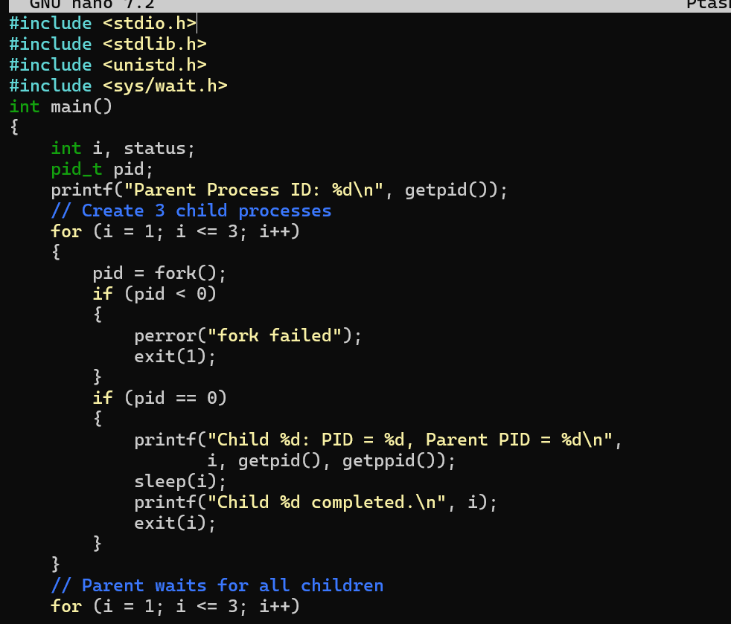

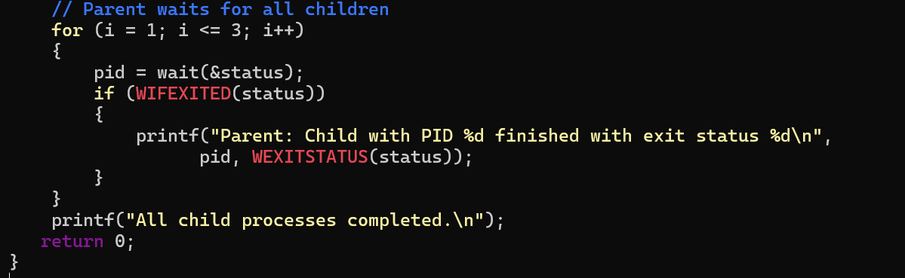
Output:
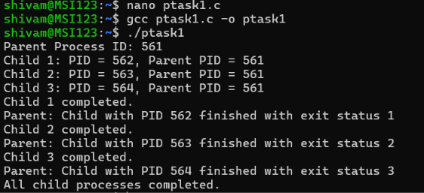

Task 2
Create a scenario where a child process becomes a zombie process. Investigate the process table and then modify the program to eliminate zombie processes using proper synchronization techniques.
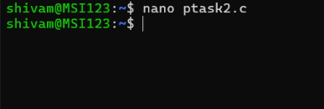

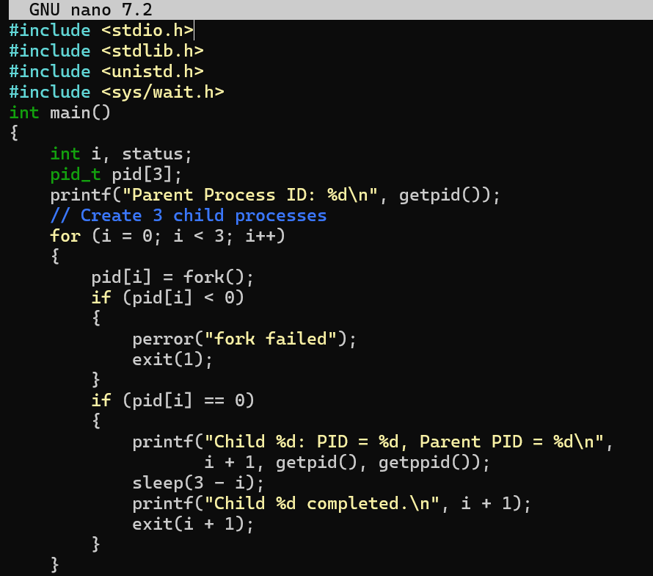

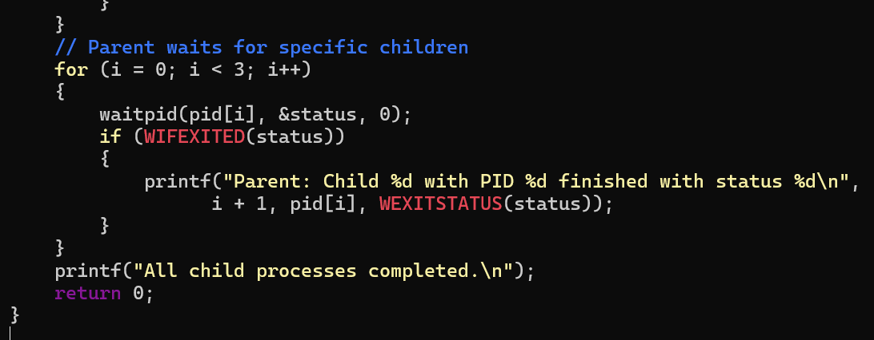
OUTPUT:

